5th C.P.N.O. INTERNATIONAL EXHIBITION OF PHOTOGRAPHY (2013) | 
中國攝影在線 -『第五屆國際攝影展覽』(2013)

主 辦 Organized by: |  |  | 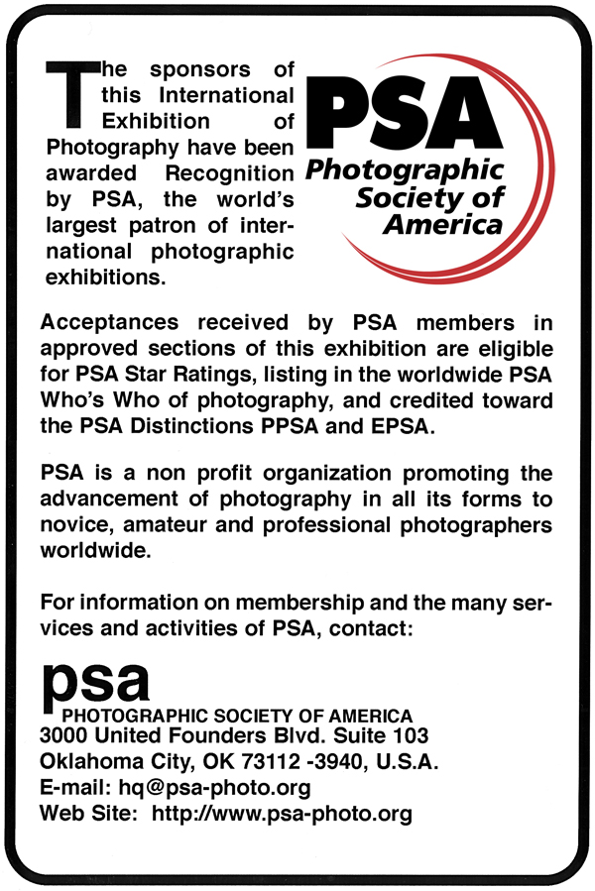
  Ce salon a recu le Haut Patronage de la FIAP
  This salon has received the high Patronage of FIAP
  Nr 2013/214
  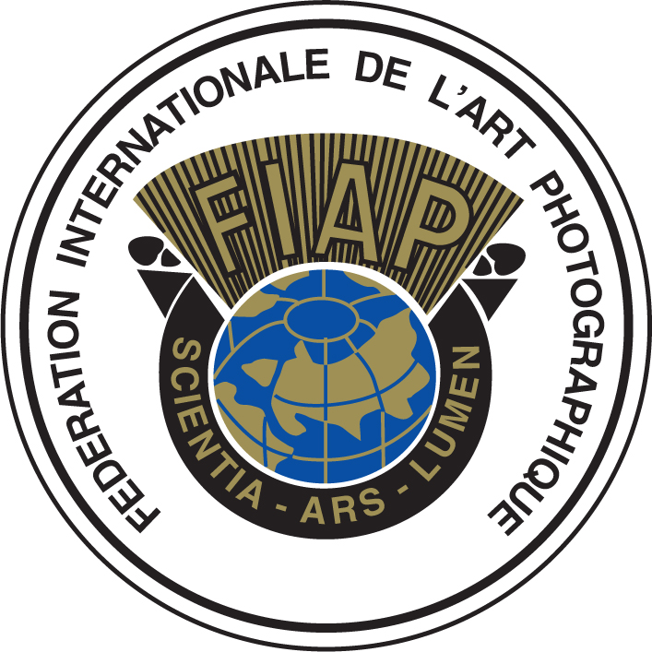
  Federation Internationale de l’Art Photographique
  The International Federation of Photographic Art
  Federations et associations nationals affiliees
  sur les cinq continents.
  National federations and associations affiliated
  on all five continents
  Distinctions photographiques mondialement reconnues.
  World-famed photographic distinctions.
  Les acceptations obtenues a ce salon
  comptent pour l’attribution des distinctions FIAP.
  Acceptances obtained in this salon
  are taken into account for FIAP Distinctions.
  FIAP Website: www.fiap.net
  Secretariat General - Secretary General
  Via Corelli 86 - 1-50127 Firenze (Italie-Italy)
  
  This International Exhibition has received Recognition by CAPA, The Canadian Association for Photographic Art.
  CAPA is a federally chartered nonprofit Association that promotes the advancement of photography in all its forms. CAPA is not an event sponsor and is not involved in the operation of this exhibition.
  Acceptances and awards obtained in this exhibition are eligible for consideration for CAPA Distinctions, ACAPA, MCAPA and FCAPA by CAPA Members worldwide.
  CAPA is Canada’s National Society for Photographers. For further information on membership please contact;
  Canadian Association for Photographic Art
  Box 357, Logan Lake BC Canada V0K 1W0
  CAPA Website: http://www.capacanada.ca
  Email: capaoffice@capacanada.ca

Drawing Times Press
讀圖時代出版社

 | 2013/000
 | 

 | EXHIBITION CALENDAR | 展 覽 日 期 表 |  | DIGITAL IMAGES 電子影像組
 | Closing date for receipt of entries | 截止收件日期 |  | 05-10-2013
 | Judging | 作品評選 |  | 19-10-2013
 | Notification Cards sent by e-mail | 發出通知卡(電子郵件) |  | 26-10-2013
 | Exhibition | 公開展覽 |  | 23-11-2013 ~ 29-11-2013
 | Catalogue sent | 寄出展覽目錄 |  | 23-12-2013

ALL CORRESPONDENCE SHOULD BE ADDRESSED TO: | 有關本屆展覽之通訊地址請寄：
Mr. WEILU CHEN  Salon Chairman  The Drawing Times Press  P. O. Box 6285, MACAU (China) | 澳門郵政信箱 6285號  讀圖時代出版社  沙龍主席 陳偉錄收啟
E-Mail : zhuhai@cphoto.net  Website: www.cphoto.net | 電郵 : zhuhai@cphoto.net  網址 : www.cphoto.net

Label for Sending Digital Images | 投寄電子影像標籤 |  | 電子影像和參加表格可經由網站  http://contest.cphoto.net 直接上載；  或經電郵：zhuhai@cphoto.net 提交。
FROM:

E-MAIL:
To: Mr. WEILU CHEN  Salon Chairman  The Drawing Times Press  P. O. Box 6285, MACAU (China) |  |  | Digital images and entry forms can be uploaded at website http://contest.cphoto.net, or submitted by E-mail with attachment to: zhuhai@cphoto.net
寄: 澳門郵政信箱 6285號  讀圖時代出版社  沙龍主席 陳偉錄收啟 |  | Please hand  Stamp  FRAGILE
Photographic Images For Exhibition Only, no Commercial Value.
國際攝影展覽之照片，無商業價值。
China Photo Network Online (a professional network of photography belongs to The Drawing Times Press) cordially invites you, photographers and photography lovers all over the world to participate in the 5th C.P.N.O. INTERNATIONAL EXHIBITION OF PHOTOGRAPHY (2013). The exhibition will take place in the Exhibition Gallery of The Plaza from 23rd to 29th November 2013, and also on the WWW.CPHOTO.NET where will be an online exhibition from 23rd November 2013 to 28th February 2014.

GENERAL CONDITIONS OF ENTRY

1. The exhibition is open to anyone; however, an entry may be rejected when the sponsoring organization or its agent, in its reasonable discretion, believes the entry does not conform to the exhibition rules and conditions.

2. The exhibition is divided into two divisions: a.) Monochrome Digital Images; b.) Color Digital Images. Entry forms for each division should be filled separately.

3. Entry fees (per entrant per division)
5th C.P.N.O. INTERNATIONAL EXHIBITION OF PHOTOGRAPHY (2013) |  | Remark:  - Entry fee is according to the country and district of the mailing address of salon catalogue and return of entries.  - Entry fees and forms could be sent either with the entries or under separate cover. Entries without full payment of fee will not be judged, forwarded nor returned. Add extra USD10 for bank charges, if pay by bank draft or money order. Remittance should by made payable to “The Drawing Times Press of Macau”. Personal Cheque is not acceptable.  - The fee can also be paid via PayPal, please pay to web@cphoto.org.
Country of Entrants | Standard Entry Fee & Postage
Entrants from China | RMB 60
Entrants from Hong Kong | HKD 70
Entrants from Macau | MOP 60
Overseas Entrants | USD 15

4. This exhibition is held in conformity with the exhibition standards and regulations of the Photography Society of America (PSA) and the International Federation of Photographic Art (FIAP). The acceptances will be sent to PSA for "Who's Who" listing and Star Ratings; and to FIAP for counting towards FIAP distinctions. Acceptance Certificate will be issued and report cards are sent via airmail.

5. Entries must originate as photographs (image-captures of objects via light sensitivity) made by the entrant on photographic emulsion or acquired digitally. By virtue of submitting an entry, the entrant certifies the work as his own and permits the sponsors to reproduce all or part of the entered material free of charge for publication and/or display in media related to the exhibition. This may include low resolution posting on a website. The exhibition assumes no liability of any misuse of copyright. Images may be altered, either electronically or otherwise, by the maker and artwork or computer graphics created by the entrant may be incorporated if the photographic content predominates subject to divisional restrictions. All final work must be on photographic film, or on electronic file, or on photographic or electronic print material, mounting excepted.

6. All submitted entries will be handled by us carefully, but we assume no liability for any loss or damage to any entries or related material. Compensation in any form will not be entertained.

7. All Entrants are entitled to receive an exquisite Exhibition Catalogue.

8. An entrant’s four images will be distributed throughout four rounds of judging. The decisions of the judges are final and without appeal.

9. Submission of entries signifies recognition of and consent to the conditions of entry mentioned above.

Requirement for Digital Images

1. A maximum of 4 Monochrome or Color Digital Images for each division. Please submit image with minimum 72 dpi resolution or above in JPEG format and a maximum of 1024 x 768 pixels. Image can be uploaded at website http://contest.cphoto.net, or submitted by e-mail attachment to the Salon Chairman at: zhuhai@cphoto.net or on CD-ROM by post to the Salon Chairman. The organizer will not be responsible for any computer errors in reading the images. Image files & CDs will not be returned.

2. Image file name must be marked by section code(m or c) and ordinal number(1-4),only using English lowercase. The file name of Monochrome section is "m1.jpg", "m2.jpg", "m3.jpg" and "m4.jpg". The file name of Color section is "c1.jpg", "c2.jpg", "c3.jpg" and "c4.jpg".

3. Images in CD-ROM, entry fees and entry forms can be submitted together to the salon chairman by registered post.

Awards

Each division of Monochrome, Color Digital Images:
- One C.P.N.O Gold Medals; three C.P.N.O Silver Medals and five C.P.N.O Bronze Medals; ten Honorable Mention Ribbons.

Special Awards

PSA Medals
In special recognition of the management of the C.P.N.O International Exhibition, the Electronic Images Division of the Photographic Society of America is presenting the 5th C.P.N.O International Exhibition 1 Gold, 1 Silver, 1 Bronze Medals and PSA Honorable Mention Ribbons which are to be awarded to the winner of excellent achievement of each division in the exhibition;

FIAP Medals
The FIAP is presenting 1 Gold, 1 Silver, 1 Bronze Medals and FIAP Honorable Mention Ribbons which are to be awarded to the winner of excellent achievement of each division in the exhibition. The FIAP Blue Badge will be awarded to the best exhibition author who has achieved the highest number of total acceptances of all the sections.

CAPA Medals (Canadian Association for Photographic Art)
The CAPA is presenting 1 Gold, 1 Silver, 1 Bronze Medal which are to be awarded to the winner of excellent achievement of each division in the exhibition.

PSSM Medals (The Photography Salon Society of Macao)
The PSSM is presenting 1 Gold, 1 Silver, 1 Bronze Medal which are to be awarded to the winner of excellent achievement of each division in the exhibition.

All correspondence should be address or contact to:
Mr. WEILU CHEN
Salon Chairman
The Drawing Times Press  P. O. Box 6285,  MACAU (China) | E-Mail : zhuhai@cphoto.net  Website: www.cphoto.net

中國攝影在線（隸屬於讀圖時代出版社的攝影專業網站），謹定於2013年11月23日至29日假座澳門萬豪軒展覽廳舉行中國攝影在線『第五屆國際攝影展覽』; 及2013年11月23日至2014年2月28日在中國攝影在線 WWW.CPHOTO.NET 網站進行網路展覽。現誠邀世界各地攝影家、攝影師及攝影愛好者選送作品參加。

參 加 簡 章

一、 本攝影展覽歡迎任何人士參加，但當主辦單位或贊助機構經謹慎審核後，認為某些參加作品並不符合本展覽章程時，可決定拒絕其參加。
二、 本屆展覽共設兩組: a)黑白數碼影像組 b) 彩色數碼影像組，每人每組限交作品四幀，各組須分別填寫參加表格。
三、 參加費 (每人每組計)：

中國攝影在線- 『第五屆國際攝影展覽』
電 子 影 像 組 | 每組參加費及郵費 | 備註：  - 參加者所屬地區及其所須繳交之一切參加費用，均按照退件及寄回沙龍目錄之地址為準。  - 所有未繳交足夠參加費用之作品，本會將不給予評選、轉交或退回。銀行匯票需另加十美元作銀行手續費，抬頭請寫「讀圖時代出版社」收，恕不接受私人支票及郵政匯票。  - 如使用CD光碟提交，可連同參加費及參加表格用掛號郵件方式一併投寄。  - 參加費亦可經由PayPal支付，收款電郵地址為 web@cphoto.org.
中國內地地區參加者 | RMB 60
香港地區參加者 | HKD 70
澳門地區參加者 | MOP 60
海外地區參加者 | USD 15

四、 本沙龍遵守美國攝影學會(PSA)及國際影藝聯盟(FlAP)所訂之條例辦理，全部入選作品皆列入美國攝影學會『名家與星標』統計及申請國際影藝聯盟之榮銜的績分依據，所有入選作品皆發給入選證，而成績通知單將由空郵或經電郵寄出。
五、 所有參加作品，必須為作者親自拍攝之作品及必須擁有該作品之所有版權及承擔板權條例之全部責任，參加者已承認所遞交之作品是其本人之作品及允許主辦機構及有關之主辦單位元可以把全部或部份作品公開展示，或用於日後的印刷品包括沙龍目錄、本機構出版之刊物、有關宣傳單張或於報章發表，或上載至主辦單位之網頁而不需負任何費用。
六、 本會將盡力小心處理所有交來之作品及所有物料，但不論任何原因而導致之損毀或遺失，本機構將不負任何責任或作任何形式之賠償。
七、 凡繳足參加費者，不論入選與否，均可免費獲贈精美沙龍目錄一份。
八、 每位參加者之投交之四張作品，將會分別於四個迴圈評選。評選團之決定為最終之決定，參加者不得異議。
九、 凡投送作品參加本屆國際沙龍，即承認並同意本簡章所訂之規約。

電子影像作品規格
一、 每人每組最多只可繳交四張作品。圖元尺寸為1024x768以下，解像度72dpi或以上，並以IBM-PC壓縮檔案JPEG為准，檔案大小為1MB或以下。影像可經由網站 http:// contest.cphoto.net 直接上載，或經電郵：zhuhai@cphoto.net 提交，或儲存於電腦磁片或CD光碟內提交沙龍主席均可，主辦單位對因網路及電腦讀取有關影像檔案出現之錯誤，概不負責，不作退件。
二、 檔案名稱：檔案名稱須由2部分組成，組別+數字 ( 只限數位，英文小寫 )，黑白組檔案名稱應如以下顯示：m1.jpg, m2.jpg, m3.jpg, m4.jpg；彩色組檔案名稱應如以下顯示：c1.jpg, c2.jpg, c3.jpg, c4.jpg,
三、 如使用CD光碟提交，可連同參加費及參加表格用掛號郵件方式一併投寄。

獎項
一、本機構獎項：
- 每組設中國攝影在線金牌各一面，銀牌三面，銅牌五面，絲帶十條。
二、特別獎項：
- 美國攝影學會數碼影像組特別認可是次展覽並送出每組金、銀、銅牌各一面及優異絲帶頒予黑白電子影像組及彩色電子影像組之優勝者。
- 國際影藝聯盟送出每組金、銀、銅牌各一面及優異絲帶頒予黑白電子影像組及彩色電子影像組之優勝者，『國際影藝聯盟藍襟章 - 最佳作者』獎項頒予在本屆國際攝影展覽所有組別取得最高總成績的參加者。
- 加拿大攝影藝術協會送出每組金、銀、銅牌各一面頒予黑白電子影像組及彩色電子影像組之優勝者。
- 澳門沙龍影藝會送出每組金、銀、銅牌各一面頒予黑白電子影像組及彩色電子影像組之優勝者。

有關本屆展覽之通訊位址請寄： | 特約收件地點：
澳門郵政信箱6285號 | 中國大陸
讀圖時代出版社 |  | 中國攝影在線（珠海） | 珠海市石花東路58號15棟首層 郵編：519105
陳偉錄收 | 澳門區
 |  | 藝真攝影沖印室 | 澳門看臺街139號南暉大廈地下
或可透過以下電子郵件及網址與展覽主席聯絡： |  | 龍影攝影沖印 | 澳門草堆街93號地下
E-Mail : zhuhai@cphoto.net

Website: www.cphoto.net

5th C.P.N.O. INTERNATIONAL EXHIBITION OF PHOTOGRAPHY (2013)
中國攝影在線 -『第五屆國際攝影展覽』(2013)

DIVISIONS 組 別 |  | Mono Digital Images  黑白電子影像 |  | Color Digital Images  彩色電子影像 |  | Official Use Only  此欄由本機構填寫

中國攝影在線 - 『第五屆國際攝影展覽』
5th C.P.N.O. INTERNATIONAL EXHIBITION OF PHOTOGRAPHY (2013)
電 子 影 像 組- Digital Images | Entry Fee 參 加 費
中國內地地區參加者 - China Entrants | RMB 60
香港地區參加者 - Hong Kong Entrants | HKD 70
澳門地區參加者 - Macau Entrants | MOP 60
海外地區參加者 - Overseas Entrants | USD 15
Total Fee Enclosed
費用:

To comply with recognition organizations’ standards and for ease of computer processing, Name, Address and Title should be in capital letter.
為符合有關認可組織之條例及方便電腦處理，姓名、位址及作品題名必須以英文正楷填寫。

No. | Title 題 名 |  |  |  |  |  |  |  |  |  |  |  |  |  |  |  |  |  |  |  |  |  |  |  |  |  |  |  |  |  |  |  |  |  |  | File Name 檔案名稱
1.
2.
3.
4.

Surname 姓氏 |  | 中文姓名 :
Given Name 名字
Honors 名銜
Address 地址
Country 國家 |  | Postal Code 郵編
Mobile Phone 手機
E-mail 電郵

CLOSING DATE : 5th October 2013 | 截止收件日期：2013年10月5日
Please Post Early, overseas entrants should check with their Postal Authorities. 90 days is normal shipping time.

＊RETURN LABELS FILL IN BUT DO NOT DETACH (回郵地址，請填上，勿剪去) ＊

From: The Drawing Times Press  P. O. Box 6285, MACAU (China) |  | From: The Drawing Times Press  P. O. Box 6285, MACAU (China)
To: |  | To:
Catalogues of Photography Exhibition. No Commercial Value.  國際攝影展覽之沙龍目錄，無商業價值。 |  | Catalogues of Photography Exhibition. No Commercial Value.  國際攝影展覽之沙龍目錄，無商業價值。

Photocopy of this Entry Form is acceptable.
歡迎使用本表格之影印本。

5th C.P.N.O. INTERNATIONAL EXHIBITION OF PHOTOGRAPHY (2013)
中國攝影在線 -『第五屆國際攝影展覽』(2013)

評 審 團 | PANEL OF JUDGES

黑白電子影像組及彩色電子影像組
Monochrome Digital Images Division and Color Digital Images Division

黎榮照先生 | Mr. LAI Wing Chiu | Macau
 | Hon. FPSSM, Hon. EPSSM, Hon. FPSEA, Hon. FPSM, FRPS, FCPA, F35mmPS, FPSEA, FHKCC, FPSNY, Hon. EHKCC, Hon. ECPA, SE35mmPS, Hon. EPAS, Hon. EYMCAPS, Hon. ESEAPS, APSA, Hon. EPSNY, Senior Associate Member of the Wilmington Int'l Exhibition, PSA Diamond Star Exhibitor.
馬志信先生 | Mr. MA Chi Son | Macau
 | Hon. FPSM, FPSM, FPSSM, FGPC, FHKPA, AFIAP, EP.PSM, ACFPA
謝炳潤先生 | Mr. CHE Peng Ion | Macau
 | Hon. FPSSM, FPSSM, Hon. FHCPS, FRPS, ASEAPS, APSM, A35mmPS, SE35mmPS
彭 邦先生 | Mr. PENG Bang | Hong Kong
 | Hasselblad Masters Awards
吳 旗先生 | Mr. WANG Qi | China
 | China's top photography award Award winner

** In case of an alternate judge is needed, a suitable person will be chosen.

展 覽 委 員 會 | EXHIBITION COMMITTEE

展 覽 主 席 |  | Exhibition Chairman
陳偉錄先生 |  | Mr. CHEN WeiLu
事 務 顧 問 |  | General Adviser
馬 剛先生 |  | Mr. MA Gang
洪火山先生 |  | Mr. HONG Fo San
楊劍文先生 |  | Mr. lEONG Kim Man
秘 書 |  | Secretary
陳 丹小姐 |  | Ms. CHEN Dan
技 術 |  | Technology
王雲青先生 |  | Mr. WANG Yun Qing
張國鋼先生 |  | Mr. ZHANG Guo Gang
展 覽 委 員 |  | Exhibition Committee Members
王雲青先生 |  | Mr. WANG Yun Qing
張國鋼先生 |  | Mr. ZHANG Guo Gang
朱元珍小姐 |  | Ms. ZHU Yuan Zhen
陳 丹小姐 |  | Ms. CHEN Dan
鐘嘉榮先生 |  | Mr. ZHONG Jia Rong

